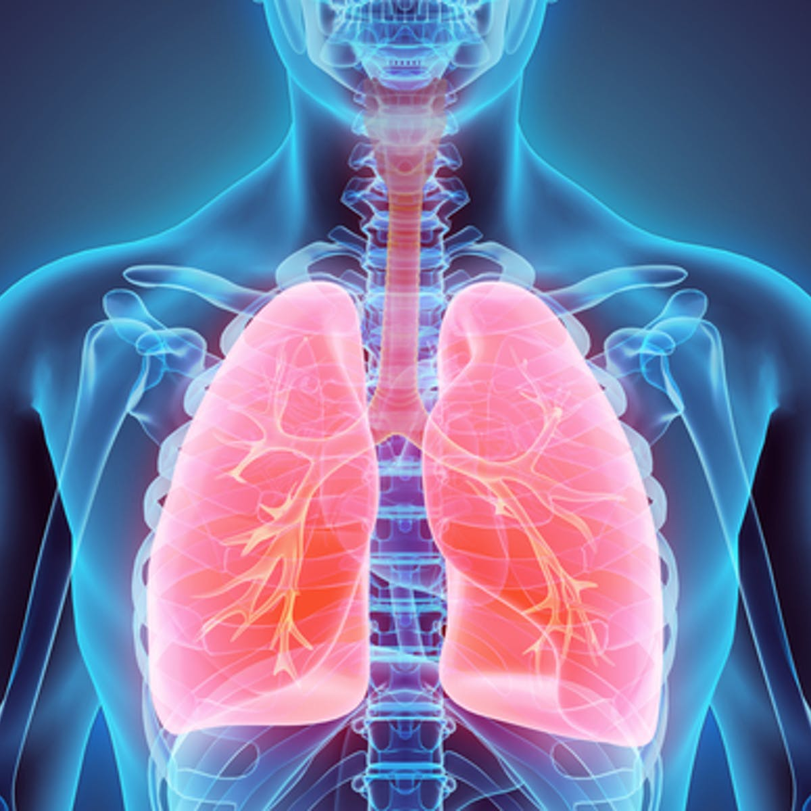

Lung Diseases & Treatment

Human biology

Willow Bright

# Cystic Fibrosis

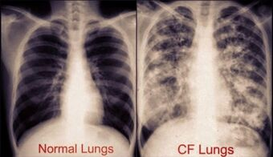Cystic fibrosis is an inherited disorder that damages the lungs and intestines, this disorder is life-threatening. Around 30,000 people in the United States have cystic fibrosis, the disease affects about 1 in 2,500 to 3,500 white newborns. It’s not as common in other ethnic groups, it affects about 1 in 17,000 African- Americans and 1 in 100,000 Asian Americans. In the United Kingdom, it is estimated that 10,500 have the disease, and about 4,000 Canadian’s have it and Australia report about 3,300 cases in 2016. Globally, about 70,000 to 100,000 people have cystic fibrosis, it affects both male and females at the same rates.

Cystic fibrosis is caused by a mutation in the cystic fibrosis transmembrane regulatory gene, CFTR. The cystic fibrosis membrane conductance regulator protein maintains the balance of salt and water on many surfaces in the body, such as the lungs. The chloride (salt component) becomes trapped in the cell when the protein is not working properly. This disorder is inherited when a child inherits a defective copy of the gene from both parents who are carriers of the gene, known as an autosomal recessive disorder. The carrier is an individual that has a defective copy and normal copy of a gene and is unaffected themselves. The chloride channel that the CFTR gene codes for the CFTR are crucial. The purpose of this channel is to ions in and out of the cell. The complications revolving around cystic fibrosis are caused by the dysfunctional CFTR protein channel, found throughout the gastrointestinal tract. This leads individuals who have cystic fibrosis to develop symptoms such as e elevated swear electrolyte levels, lung infections, and pancreatic insufficiencies. However not all patients have these symptoms due to the range of severity this disease has, every patient is different. The survival rate of individuals who possess cystic fibrosis in the mid-1900s was eight years; however, the current survival rate has improved to thirty years due to the enhancement of medicine and the advancement in understanding the disease. The underlying cause of cystic fibrosis is due to genetics, more than 1,500 genetic mutations have been linked to the origin of the disease. The lungs are the primary organ that is being affected by cystic fibrosis. The excessive mucus which generates infections, causes bacteria to be trapped. Another issue that occurs is the effect on digestive functions because the excessive amount of mucus blocks digestive enzymes from reaching the intestines. Hence the fats and proteins are not digested correctly in the individual’s body. Cystic fibrosis affects the upper respiratory tract, the epithelium, which causes inflammation and infection of the sinuses to be another frequent effect of the disease.

The diagnosis of cystic fibrosis requires clinical symptoms consistent with CF in one organ system and evidence of CFTR dysfunction. The diagnostic tests include the immunoreactive trypsinogen (IRT) test, which is a screening test of a newborn that checks for abnormal levels of the protein. Sweat chloride test, checks for increased levels of salt in the sweat, it is performed by using a chemical that makes the skin sweat when triggered by a weak electrical current. A sputum test is when a sample of mucus is taken. Chest x-ray helps reveal any swelling in the lungs due to blockages in the airways. A variety of treatments have been discovered to avert infections in the patient’s lungs by eliminating mucus to stop the obstruction in the intestines. People who have cystic fibrosis undergo several treatments such as antibiotics to help clear the airway, chest therapy, and other particular medications. The antibiotics used for cystic fibrosis patients are when infections in the lungs occur, due to the extensive variety of this disease there are specific types of antibiotics used for each patient. The processes that involve administrating the antibiotics are inhaled, oral or intravenous antibiotics. Another type of treatment includes chest physical therapy, which helps to remove the mucus from the lungs. This treatment is done 3 to 4 times a day, the way it works is the repetition of pounding on the individual’s chest. This process can be demanding, there is an alternative device such as mechanical precursors or a positive expiratory pump mask. the purpose of this technique is to clear the mucus from the airways. Another issue revolving around cystic fibrosis is the cause of malnutrition due to the difficulty to digest food. To help prevent this from occurring oral pancreatic enzymes are given to help digest fats and proteins. By administrating these specific treatments, it helps to reduce the extent of cystic fibrosis.

# Pneumonia

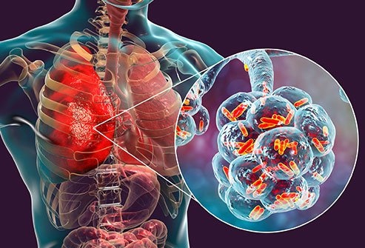Pneumonia is an infection located in the lung tissue caused by microbes that creates inflammation, this infection can range from mild to serve. Pneumonia occurs when an infection causes the alveoli (air sacs) to fill with fluid or pus. This can make it difficult for a person with pneumonia to breathe in a sufficient amount of oxygen to reach their bloodstream. All people are at risk of receiving pneumonia, however people over the age of 65 and under the age of 2 are at a higher risk of getting it, this is due to their immune systems being incapable and too weak to fight it off. The symptoms of pneumonia vary from person to person; however, the symptoms develop over a few days. Common symptoms of pneumonia include chest pain when trying to breathe or cough, fatigue and loss of appetite, shortness of breath, nausea, vomiting, and diarrhea, and cough that produces phlegm or mucus. The cause of pneumonia includes bacteria, viruses, or fungi, these can generate from flu viruses, bacteria called streptococcus pneumonia and mycoplasma pneumonia, cold viruses, RSV viruses, etc. There can be complications from pneumonia if it is not treated properly and efficiently, these include bacteraemia; this is when bacteria spreads to the blood and can cause septic shock and organ failure, trouble breathing; might cause the individual to be put on a breathing machine while their lungs heal, and lung abscess; this is when a pocket of pus forms inside or around the lungs.

Diagnosis of pneumonia starts from visiting a doctor, who will assess the patient, and if pneumonia is suspected the following tests may be recommended by the doctor; blood test, to confirm the infection and help identify it. A chest x-ray helps determine the location and extent of the infection. Pulse oximetry, to measure the oxygen level in the blood. Sputum test, a sample of fluid from the lungs is taken after a cough and analysed. The treatment used for curing pneumonia and preventing any further complications is the following: antibiotics, due to there being different types of pneumonia specific antibiotics are used for each type of pneumonia. Cough medicine can be used to help soothe the coughing, however, stopping coughing is not advised as coughing helps loosen and move the fluid from the lungs. Fever reducers/pain relievers help to subdue any discomfort the individual may feel.

# References

*Cystic Fibrosis, McMaster University, 2016*

<https://healthsci.mcmaster.ca/demystifying-medicine/video-library/cf>

*Cystic Fibrosis by the Numbers: Facts, Statistics and You, Healthline, Ann Pietrangelo, 2020*

<https://www.healthline.com/health/cystic-fibrosis-facts>

*Basics of CFTR the Protein, Cystic Fibrosis Foundation, 2017*

<https://www.cff.org/Research/Research-Into-the-Disease/Restore-CFTR-Function/Basics-of-the-CFTR-Protein/>

*What is Cystic Fibrosis? Demystifying Medicine, Zubair Banoor, Jaskeerat Kaur, Sina Nastarani, Monica Persaud and Kritika Seth, 2016*

<https://www.youtube.com/watch?v=k4U5wyPzxJE>

*Cystic Fibrosis, Healthline, Abdul Wadood Mohamed, 2020*

<https://www.healthline.com/health/cystic-fibrosis#symptoms>

*Pneumonia, Mayo Clinic, 2020*

<https://www.mayoclinic.org/diseases-conditions/pneumonia/diagnosis-treatment/drc-20354210>

*Pneumonia, WebMD, Jennifer Robinson, 2020*

<https://www.webmd.com/lung/understanding-pneumonia-basics>